
LASIK
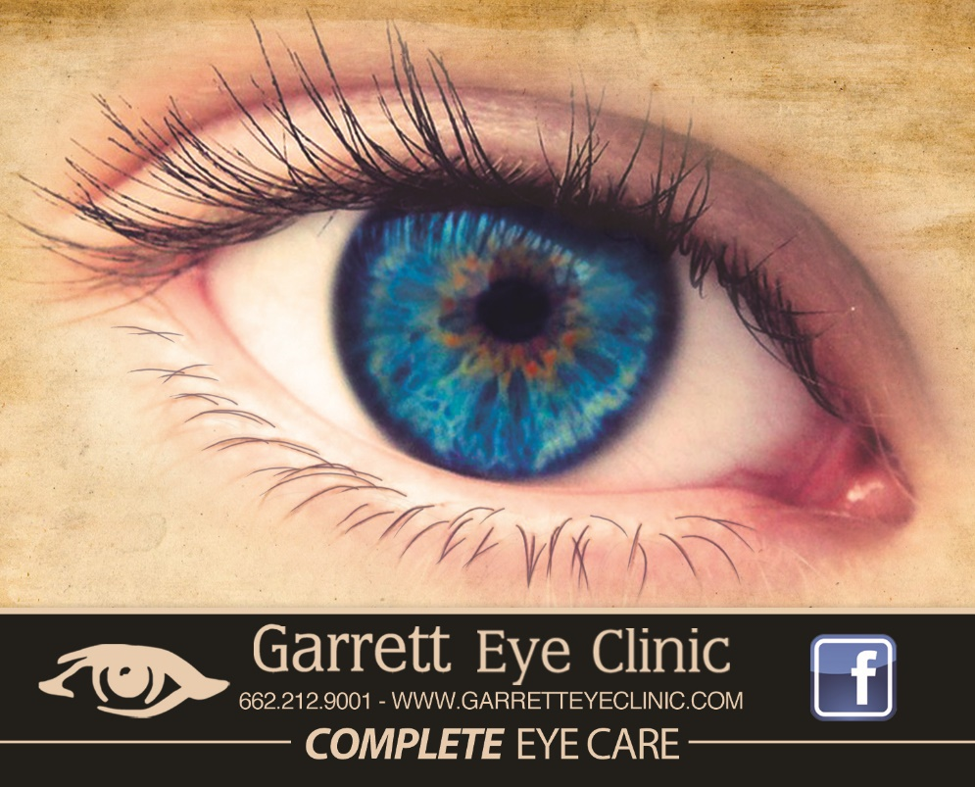
--------------------------COMPLETE EYE CARE--------------------------

GARRETTEYECLINIC.COM 662.212.9001

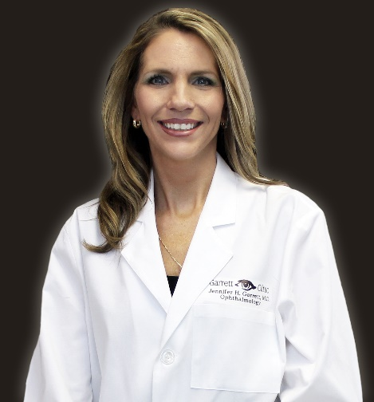
Jennifer H. Garrett, MD
Board Cerified Ophthalmologist
Almost 20 years experience performing LASIK and Cataract surgery
After graduating as the Valedictorian at the Corinth High School in 1993, she then graduated as Summa Cum Laude at Mississippi State University while earning a Bachelor of Science degree in Biochemistry and Molecular Biology. In, 1997 she began medical school at the University of Mississippi School of Medicine. After completing her training there, she earned a Doctorate of Medicine degree. She then completed a 1 year internship in Internal Medicine at the University of Mississippi Medical Center. Lastly, she completed a three year residency in Ophthalmology in Jackson, Mississippi.
A few months later, she returned to her hometown of Corinth and began practicing Ophthalmology. In addition to performing LASIK surgery, she also performs cataract surgery. During catarct surgery, she able to insert numerous types of implants to correct and improve distant vision and near vision as well several of the newest intraocular lens technologies. Blepharaplasty, commonly known as eyelid surgery, is yet another service she performs while in surgery. Utilizing the the latest technology in her office, she is able to diagnose and treat diseases of the eye. In addition, she proudly practices general Ophthalmology by performing routine eye exams and prescibing glasses as well as contact lenses. The optical dispensary, Glamnificent, is located inside her office and offers the area’s best selection of stylish designer frames and sunglasses. Prescription sunglasses are also available.

Z LASIK logo
What is Z LASIK?
Z LASIK is better recognized as Bladeless LASIK. This procedure, which is conveniently done in Dr. Garrett’s office, has become a proven, technological breakthrough. Patients who were previously afraid of traditional LASIK are excited about the ability to use a Da Vinci series laser to begin their surgery. This Ziemer FEMTOSECOND laser enables Dr. Garrett to provide the highest level of safety and comfort as well as the greatest potential to achieve great vision.
Advantages of Bladeless Z-LASIK vs regular LASIK
- Due to the extremely low impact to the eye, Z-LASIK is more comfortable and often painless.

- More patients qualify for Z-LASIK due to the thinner flap created by a FEMTOSECOND laser.

- Z-LASIK is safer and has a shorter recovery period compared to other LASIK techniques.
FEES FOR SERVICE
This cost for this elective procedure includes the initial LASIK evaluation, testing associated with this procedure, and all pre-operative appointments. This amount also covers all fees for the surgery itself--such as the facility fee, surgeon fee, and laser fees. We provide CUSTOMVUE LASIK to all patients that qualify without any additional cost to you. Also, all of your post-operative appointments are covered for an entire year.
COST $4,900

CASH DISCOUNT $500

*VISION INSURANCE DISCOUNTS UP TO: $980
*Vision insurance plans offer discounts from 5% to 20% off of LASIK. Check with your vision insurance company to see how much of a discount you are entitled to receive.
We honor ALL vision insurance plans.
0% financing for 24 months
That’s less than $205 per month!
4
Are you a candidate for LASIK?

Once you have made an appointment for a LASIK evaluation, be sure to stay out of your contact lenses for at least two weeks before your appointment. Since contact lenses reshape the surface of your eye, it is imperative that you remain out of your contacts for this period of time. There are many tests that go above and beyond the traditional eye exam during a LASIK evaluation. Be prepared for a 3 to 3 ½ hour visit that day. Although LASIK corrects Myopia(Near sightedness), Hyperopia(Farsightedness), and Astigmatism, not every person is a candidate due to an excessive refractive errors or cornea thinness.
What should I expect on the day of surgery?
After taking the first of three valiums the doctor prescribes to you to help calm your nerves the night before surgery, you will arrive at your designated surgery time and then take the second valium. After that, you will have your cornea scanned to see if a “Customvue” (Amos. Please put custom vue logo here in place of text that is in the quotation marks and a customvue picture somewhere in this area) treatment would be beneficial for your eyes. A VISX Customvue treatment precisely analyzes your eye’s unique imperfections so that the doctor can accurately guide the laser to correct your vision. In essence, custom LASIK takes your unique “fingerprint” of irregularities and provides a more specific HD treatment for you eyes versus conventional treatments.
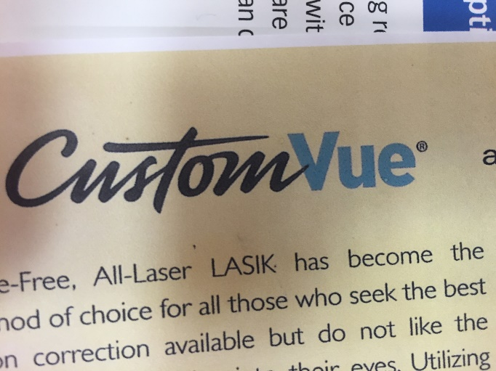
Next, the information will be plugged in to the computer of the STAR S4 IR excimer laser that will be used to correct your vision. At this point, your doctor will begin making the flap in the cornea of your eye. In it’s beginning, original LASIK made a flap on the surface of your with a metal blade called a microkeratone. Even though this outdated technique was relatively safe, using a modern approach to make the flap, offers several benefits in safety and overall outcome. In June
6
2010, Dr. Garrett introduced this groundbreaking technology of a femtosecond laser to the Crossroads area. A femtosecond laser sends rapid pulses of light to make a thinner, more accurate flap that follows the contour of the cornea unlike the metal micro-keratome blade that cuts straight across the cornea.
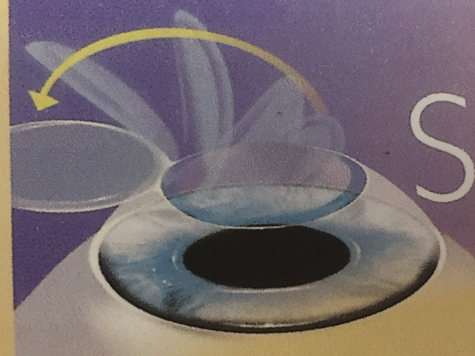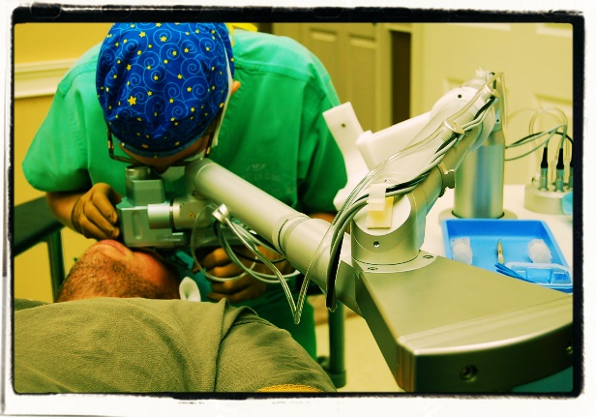
After the flap is made, it is then comfortably folded back to begin the reshaping of the cornea to correct all of the eye’s irregularities. After less than a minute, the excimer laser has reshaped the cornea and the flap is then laid back to rest on the cornea. You are then sent home to take a short nap. You will have a follow-up exam the next day to chart your progress, followed by a 1 week, 1 month, and 1 year appointments. Most patients are able to return to work the next day.
7

PRK—Photorefractive Keratectomy

Sometimes, due to the thickness of your cornea, the only LASIK technique available is PRK. PRK stands for Photorefractive Keratectomy. In this type of a procedure, the epithelium, which is the outmost layer of the front surface of the eye, is removed with a special instrument. Then the STAR 4 EXCIMER Laser is used to the reshape the cornea…similar to Z LASIK but without a flap. After surgery is finished, a bandage contact is placed over the eye while it heals. This may take several days for the epithelium to heal. Typically there is some level of discomfort such as pain and sensitivity to light for a few days after surgery. Your vision may be a little blurry for a few days while the eye is healing. Complete healing may take up to a month or a little longer. Until it is fully healed, your eye’s clarity may not be 100%. The final outcome of your vision is comparable to the results of Z LASIK with the flap.
8

